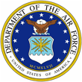
 | 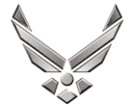

U N I T E D S T A T E S A I R F O R C E
MASTER SERGEANT TIMOTHY A LAMBERT
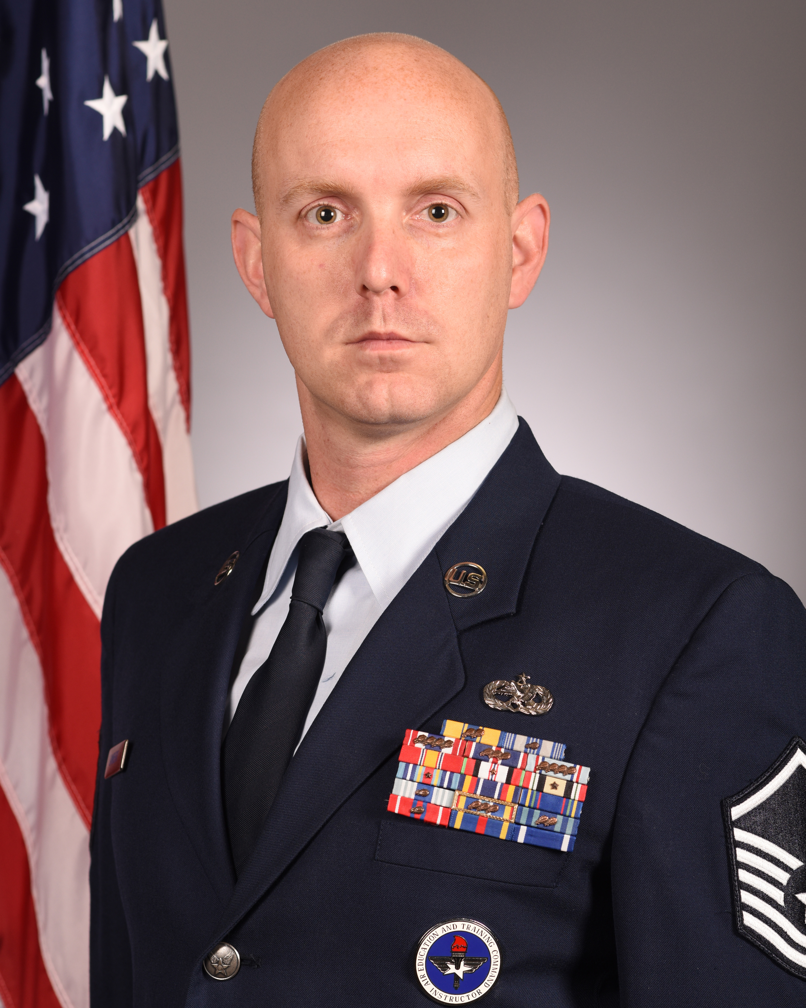
Master Sergeant Timothy A. Lambert is an F-16 Integrated Avionics Instructor, 372 Training Squadron, Detachment 202, Shaw Air Force Base, South Carolina. As an Avionics instructor, he provides mission essential F-16 aircraft maintenance training on Integrated Avionics Systems. These systems are comprised of Attack Control Systems, Flight Controls, Instrumentation, Communications, Navigation, Penetration Aids and wire repair techniques integrated into four different avionics courses.

Sergeant Lambert is from Madison, West Virginia. He enlisted in the Air Force in February of 2003. His first duty station was at Luke A.F.B., Arizona where he was assigned to the 310th Aircraft Maintenance Unit. In November of 2005 Sergeant Lambert was assigned to 18th Aircraft Maintenance Unit, Eielson AFB, Alaska. Once that assignment was complete he was assigned to the 79th Aircraft Maintenance Unit Shaw AFB., South Carolina. During his career Sergeant Lambert has been on four deployments including: Balad A.B., Iraq in support of Operation Iraqi Freedom in 2009, Al Jaber A.B, Kuwait in support of Operation New Dawn in 2011/2012, Muwaffaq Salti A.B., Jordan in support of Operation Resolute Support in 2013/2014, and lastly to Bagram A.B. Afghanistan in support of Operation Inherit Resolve in 2016/2017. In October 2017, he was selected for a Field Training Instructor position at the 372nd Training Squadron/ Detachment 2, also at Shaw AFB.

EDUCATION

2003 F-16 Integrated Avionics Tech School, Sheppard AFB, Texas
2006 Airman Leadership School, Eielson AFB, Alaska
2012 Noncommission Officer Academy, McGhee – Tyson ANG base, Tennessee
2014 Associate of Science in Avionics Maintenance Technology, Community College of the Air Force
2016 Bachelor of Science in Information Technology, Software Programming, Colorado Technical University Online
2017 Air Force Basic Instructor Course, Sheppard AFB, Texas
2018 Associates in Instructor of Technology and Military Science , Community College of the Air Force

ASSIGNMENTS

1. Oct 2003 – Nov 2005, F-16 Avionics systems Apprentice, 310th AMU, Luke AFB, AZ
2. Nov 2005 – Nov 2009, F-16 Avionics Systems Journeyman, 18th AMU, Eielson AFB, AK
3. Nov 2009 – Oct 2017, Specialist Expediter, Shaw AFB, SC
4. Oct 2017 – Present, F-16 Integrated Avionics Instructor / Trainer Development, 372nd TRS, Shaw AFB, SC
MAJOR AWARDS AND DECORATIONS
Air Force Commendation Medal w/ 2 Oak Leaf clusters
Air Force Achievement Medal w/ 1 Oak Leaf cluster
Meritorious Unit Award w/ 1 Silver Oak Leaf cluster
Afghanistan Campaign Medal
Iraq Campaign Medal
Air Force Expeditionary Service Ribbon with Gold Border w/ 3 Oak Leaf clusters

EFFECTIVE DATES OF PROMOTION
Staff Sergeant, June 2007
Technical Sergeant April 2012
Master Sergeant Sept 2018

