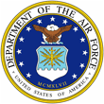
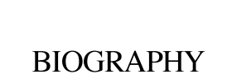 | 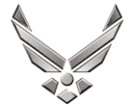

U N I T E D S T A T E S A I R F O R C E
TECHNICAL SERGENT JACOB M CASEY
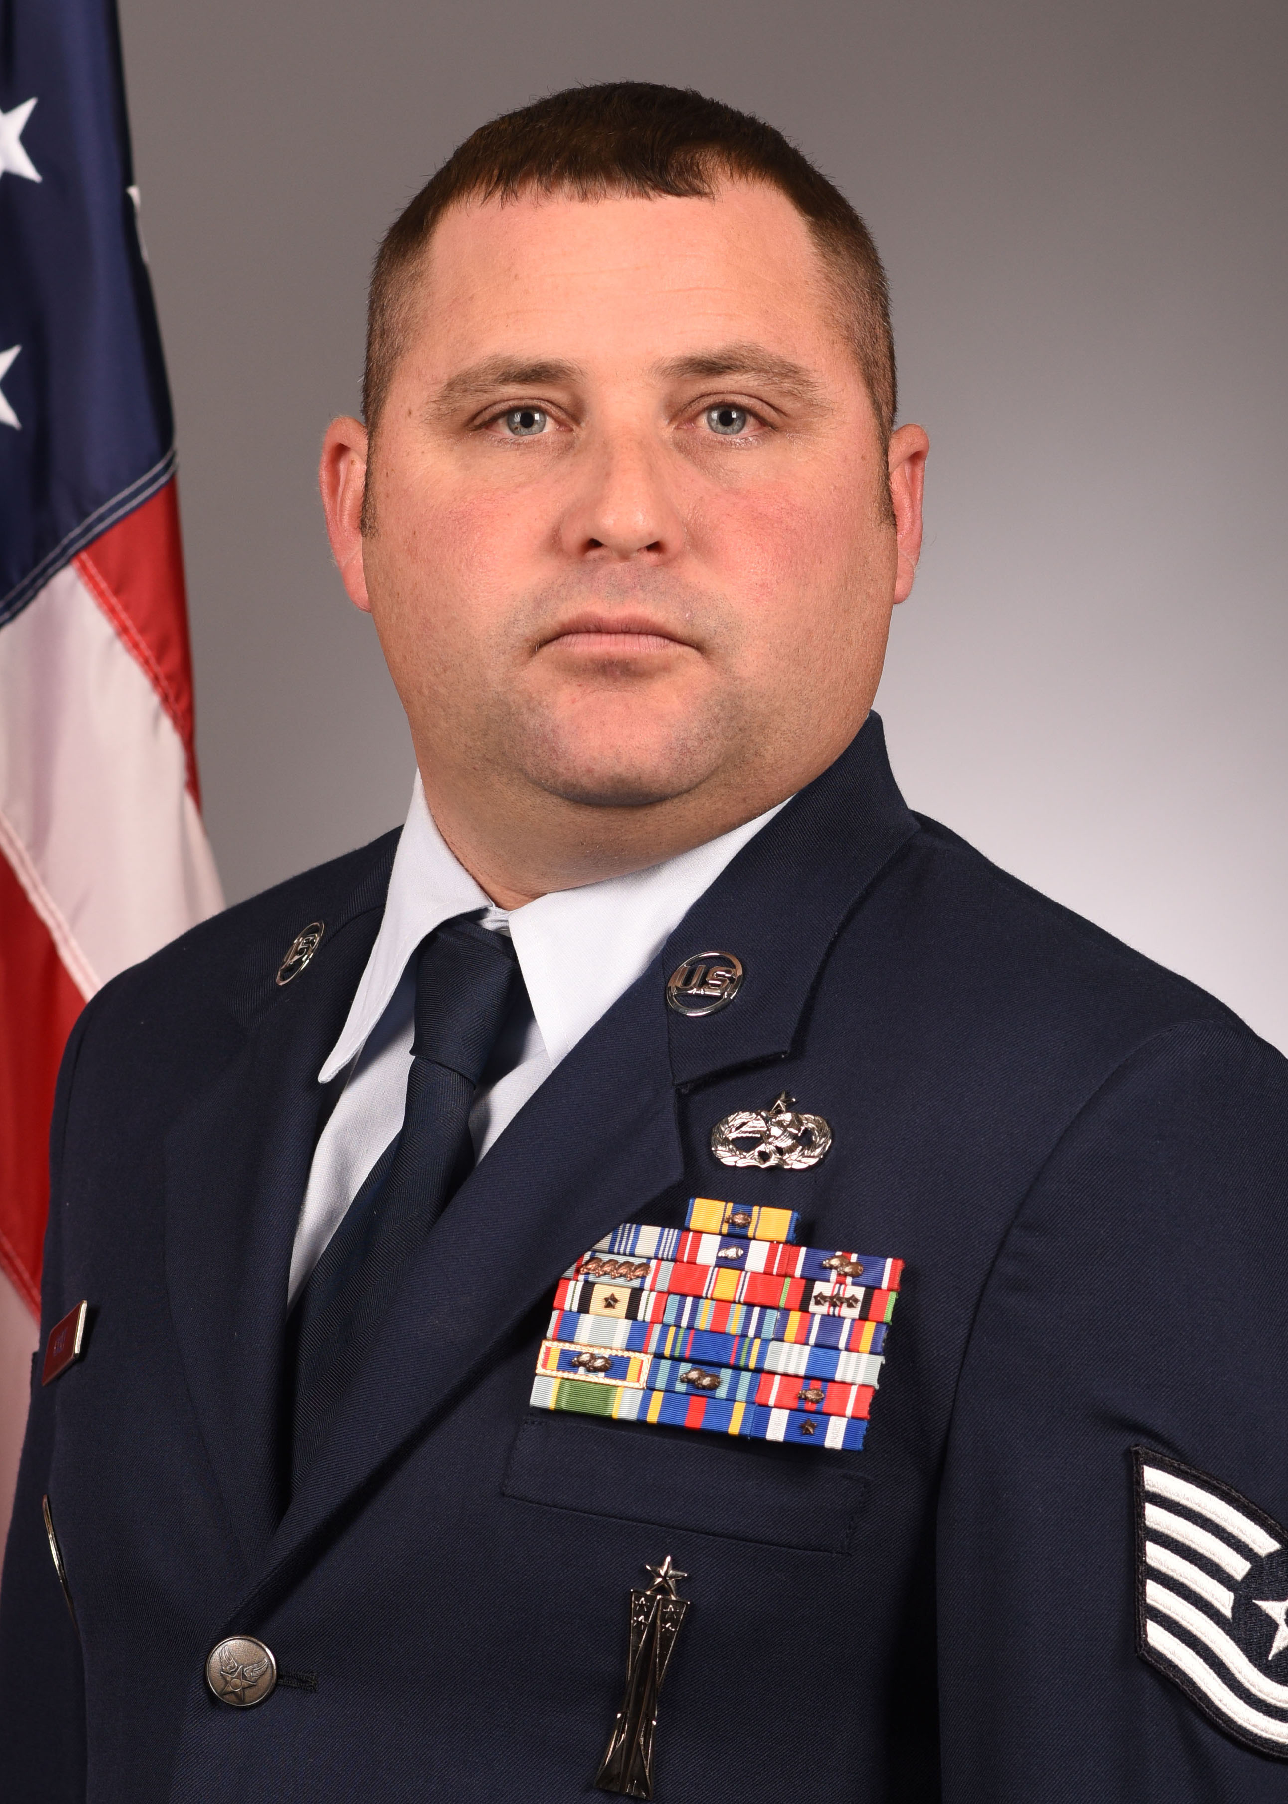
Technical Sergeant Jacob M. Casey is an F-16 Armament Systems Instructor, 372 Training Squadron, Detachment 202, Shaw Air Force Base, South Carolina. As an F-16 Armament Instructor, Sergeant Casey provides mission essential F-16 aircraft maintenance training on six different intermediate and organizational level weapons courses. He serves as a subject-matter expert and provides maintenance support to resolve training deficiencies for the 20th Fighter Wing.

Sergeant Casey is from Orlando, Florida, married with 2 children. He enlisted in the Air Force in June 2003. His background includes F-16 load crew member, Armament Maintenance Crew Member, Armament Maintenance Crew Chief, Quality Assurance Inspector, Weapons Load Crew Chief, and Weapons Expediter. He has served in 2 major commands at 2 different bases. As a Weapons System Maintainer he has completed numerous deployments in direct support of OPERATIONS Iraqi Freedom, Enduring Freedom, Unified Protector, and Odyssey Dawn.

EDUCATION

2003 F-16 Aircraft Armament Tech School, Sheppard AFB, Texas
2007 Airman Leadership School, Shaw Air Force Base, South Carolina
2008 Aircraft Armament Systems 7-Level, Technical School
2009 Associate in Aircraft Armament Systems Technology, Community College of the Air Force
2015 Non-Commissioned Officers Course, McGee-Tyson AB, Tennessee
2018 Air Force Basic Instructor Course, Sheppard AFB, Texas

ASSIGNMENTS

1. Dec 2003 - Dec 2006, F-16 Weapons Load Crew Member, Aviano AB, Italy
2. Dec 2006 - Jan 2008, Armament Maintenance Crew Member, Shaw AFB, South Carolina
3. Jan 2008 - Aug 2011, Armament Maintenance Crew Chief, Shaw AFB, South Carolina
4. Aug 2011 - Aug 2014, Quality Assurance Inspector Shaw AFB, South Carolina
5. Aug 2014 - Mar 2015, Weapons Load Crew Chief, Shaw AFB, South Carolina
6. Mar 2015 - Sep 2018, Weapons Expediter, Shaw AFB, South Carolina
7. Sep 2018 - Present, F-16 Armament System Instructor, 372d TRS, Det 202 Shaw AFB, South Carolina
MAJOR AWARDS AND DECORATIONS
Air Force Commendation Medal with 1 Oak Leaf Cluster
Air Force Achievement Medal
Meritorious Unit Award with 5 Oak Leaf Clusters
Air Force Outstanding Unit Award with two Oak Leaf Clusters
Air Force Good Conduct Medal with 4 Oak Leaf Clusters
Afghanistan Campaign Medal with 3 Service Stars
Iraq Campaign Medal with 1 Service Star
Global War on Terrorism Service Medal
Air & Space Campaign Medal
Nuclear Deterrence Operations Service Medal
Air Force Expeditionary Service Ribbon with Gold Border with 2 Oak Leaf Clusters
EFFECTIVE DATES OF PROMOTION
Staff Sergeant, January 2008
Technical Sergeant, August 2015

