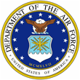
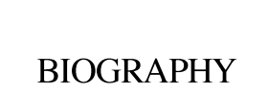 | 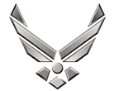

U N I T E D S T A T E S A I R F O R C E
TECHNICAL SERGEANT JOSHUA P. BERARD
Technical Sergeant Joshua P. Berard is an F-16 Tactical Aircraft Maintenance Instructor, 372 Training Squadron, Detachment 202, Shaw Air Force Base, South Carolina. As a TAMS instructor he provides F-16 maintenance training to include theory of operation, servicing, and inspecting to 5- and 7-level technicians. He prepares plans of instruction, develops measurement examinations, and performs annual reviews of 5 courses. He serves as a subject-matter expert and provides maintenance support to resolve training deficiencies for the 20th Fighter Wing.

Sergeant Berard is from Lake St. Louis, Missouri. He enlisted in the Air Force in March 2010. His background includes Assistant Dedicated Crew Chief, Dedicated Crew Chief, Transient Alert Maintenance Technician, Support Section Technician, and F-16 FTD TAMS Instructor. He has served in 4 major commands at 4 different bases. As a Tactical Aircraft Maintainer he has completed deployments in direct support of OPERATIONS Noble Eagle, Odyssey Dawn, New Dawn, and Inherent Resolve.

EDUCATION

2008 Bachelors of Fine Art, University of Arizona
2010 F-16 Tactical Aircraft Maintenance Tech School, Sheppard AFB, Texas
2014 Airman Leadership School, Lajes Field, Portugal
2015 Associate in Aviation Maintenance Technology, Community College of the Air Force
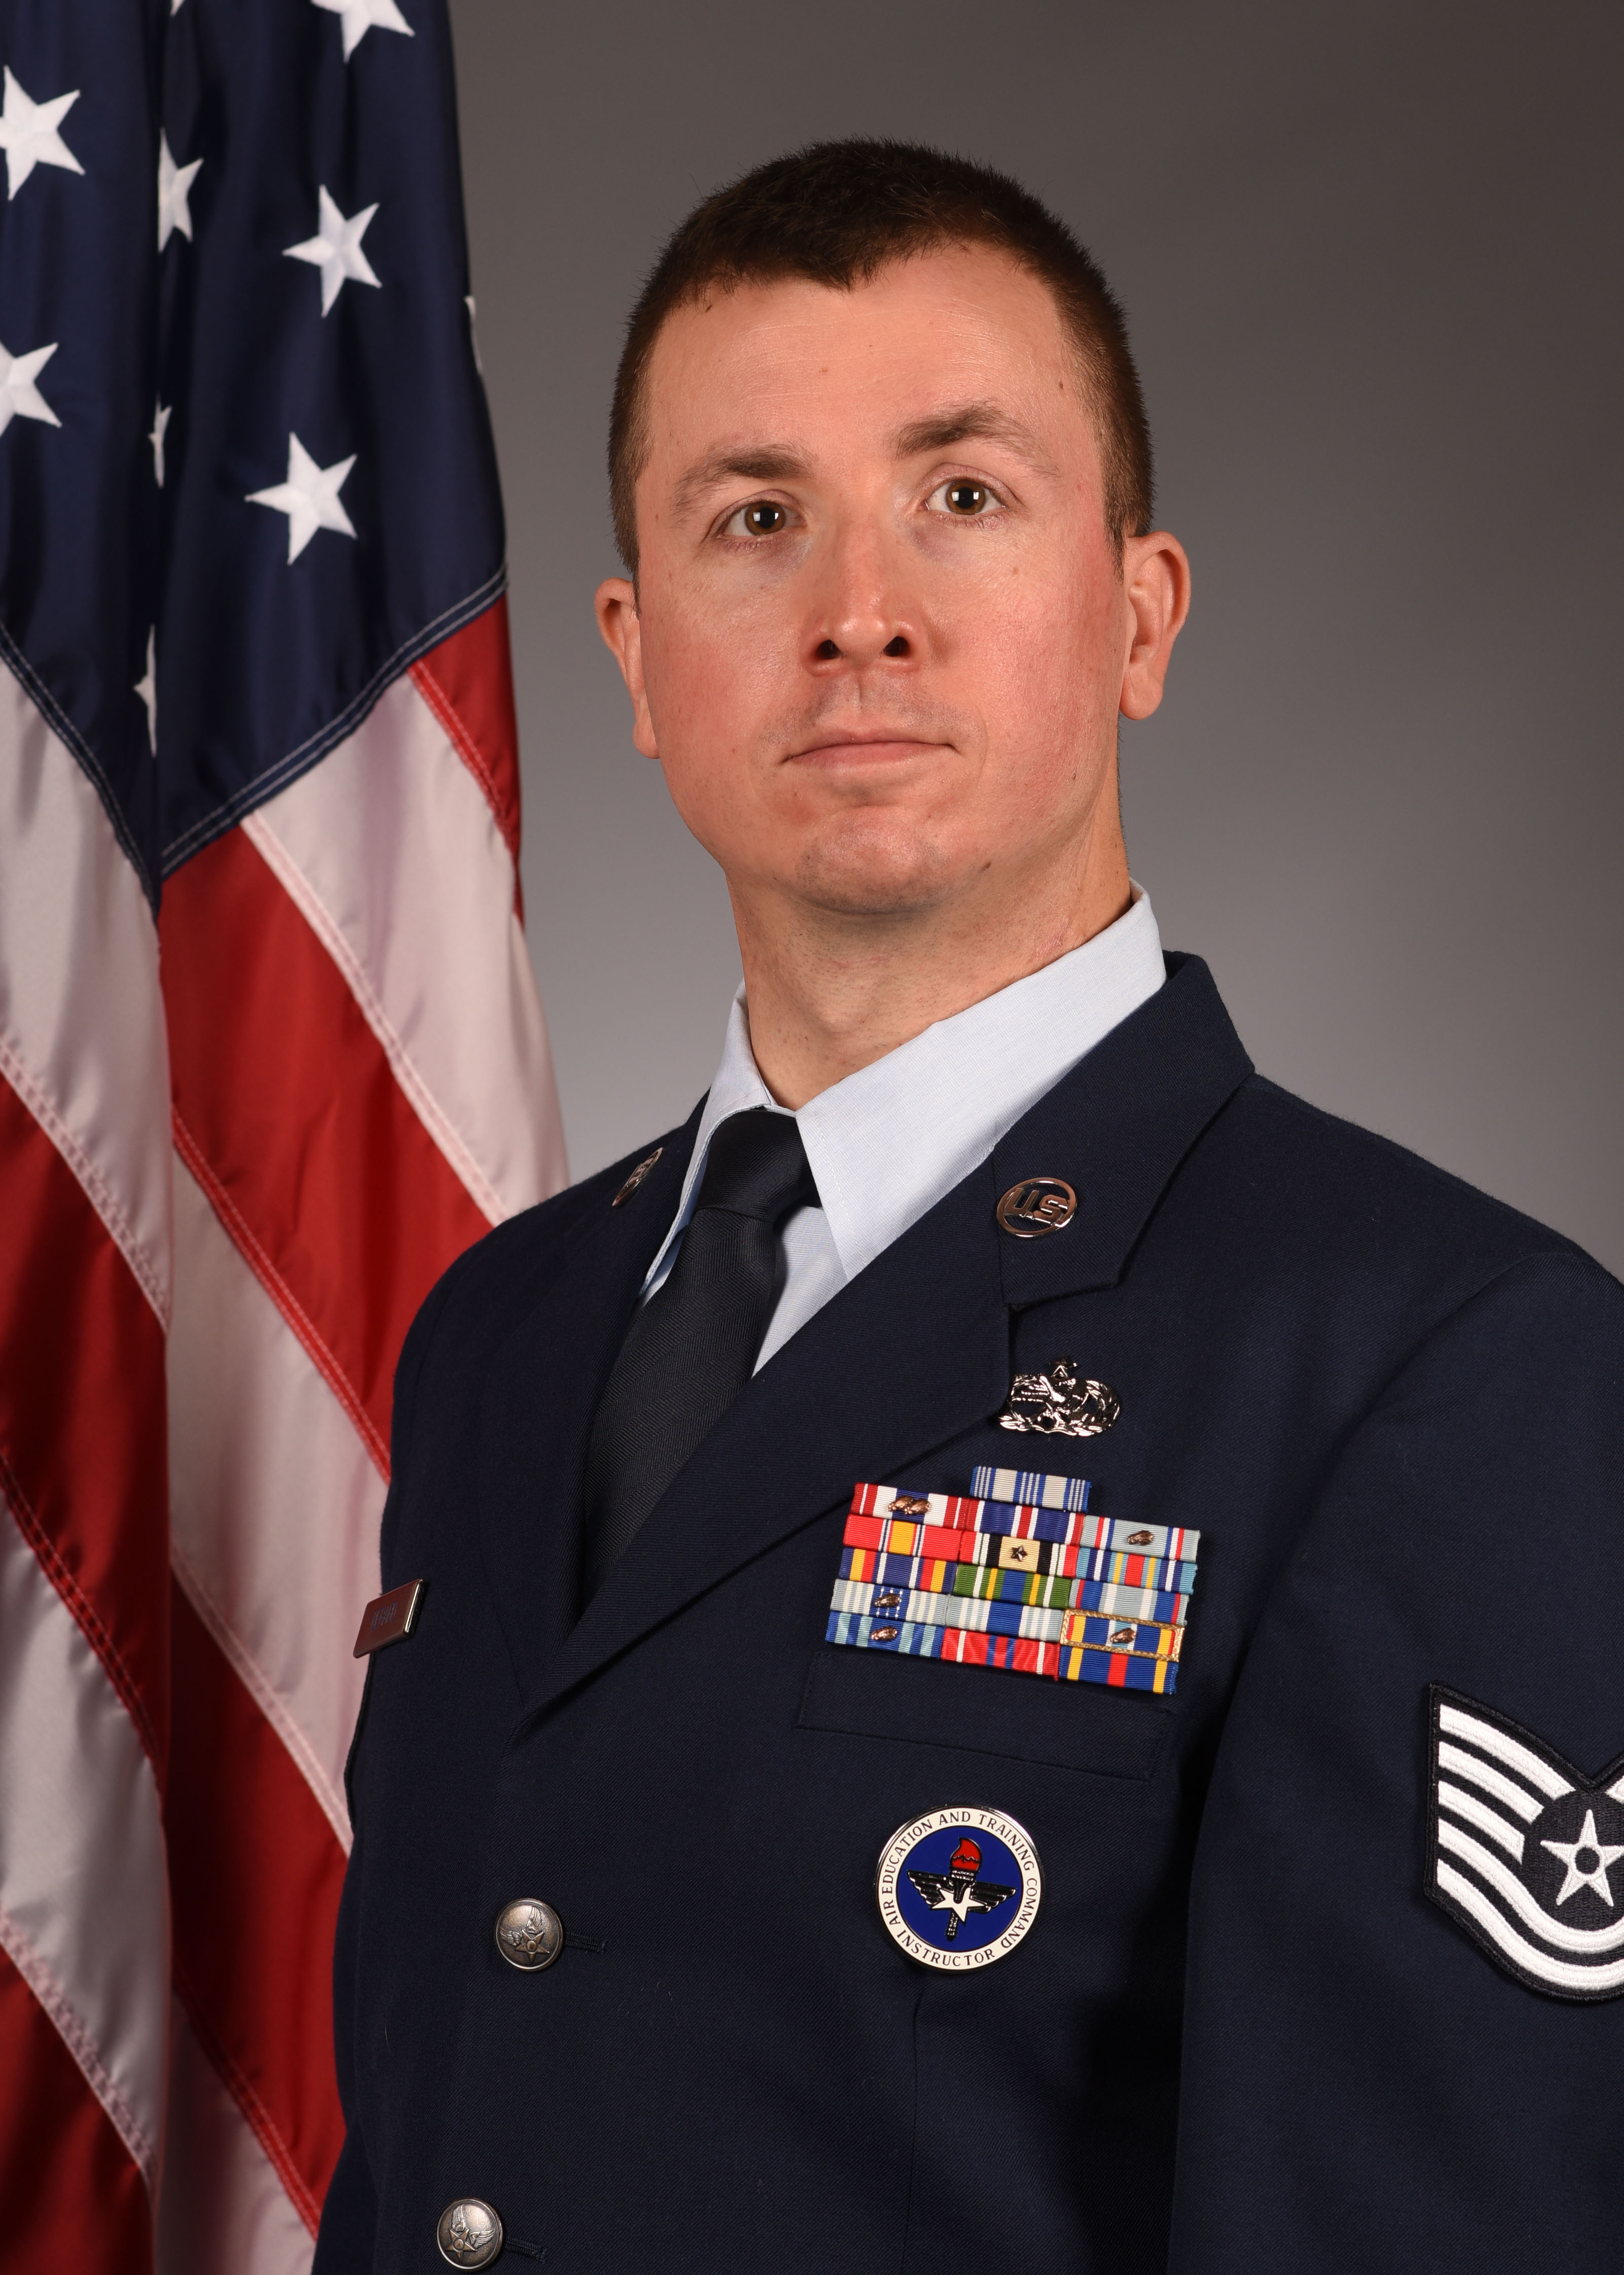
2018 Air Force Basic Instructor Course, Sheppard AFB, Texas
2019 Associate in Instructor of Technology and Military Science, Community College of the Air Force

ASSIGNMENTS

1. Nov 2010 – Nov 2012, F-16 Assistant Dedicated Crew Chief, 480th AMU, Spangdahlem AB, Germany
2. Dec 2012 – Dec 2013, F-16 Assistant Dedicated Crew Chief, 36th AMU, Osan AB, ROK
3. Jan 2014 – Jan 2015, F-16 Transient Alert Maintenance Technician, Lajes Field, Portugal
4. Feb 2015 – Mar 2016, F-16 Dedicated Crew Chief, 55th AMU, Shaw AFB, South Carolina
5. Mar 2016 – Dec 2017, Support Section Technician, 55th AMU, Shaw AFB, South Carolina
6. Jan 2018 – Present, F-16 TAMS Instructor, 372nd Training Squadron, Detachment 202, Shaw AFB, South Carolina
MAJOR AWARDS AND DECORATIONS
Air Force Achievement Medal
Meritorious Unit Award with two Oak Leaf Clusters
Iraq Campaign Medal
Global War on Terrorism Expeditionary Medal
Global War on Terrorism Service Medal
Korean Defense Medal
Air & Space Campaign Medal
EFFECTIVE DATES OF PROMOTION
Staff Sergeant, Nov, 2015
Technical Sergeant, Mar, 2019

