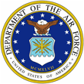
 | 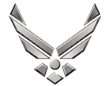

U N I T E D S T A T E S A I R F O R C E
TECHNICAL SERGEANT LAVERNE G BORST
Technical Sergeant LaVerne Borst is an F-16 Electrical & Environmental Systems Instructor assigned to the 372nd
Training Squadron, Detachment 2, Shaw Air Force Base,
South Carolina. Sergeant Borst Provides mission essential
F-16 aircraft maintenance training on 2 different intermediate
and organizational level electrical & environmental courses. These include flightline and backshop courses such as
electrical and environmental system component familiarization and theory of operation.

Technical Sergeant LaVerne Borst is from Fort Plain, New York.
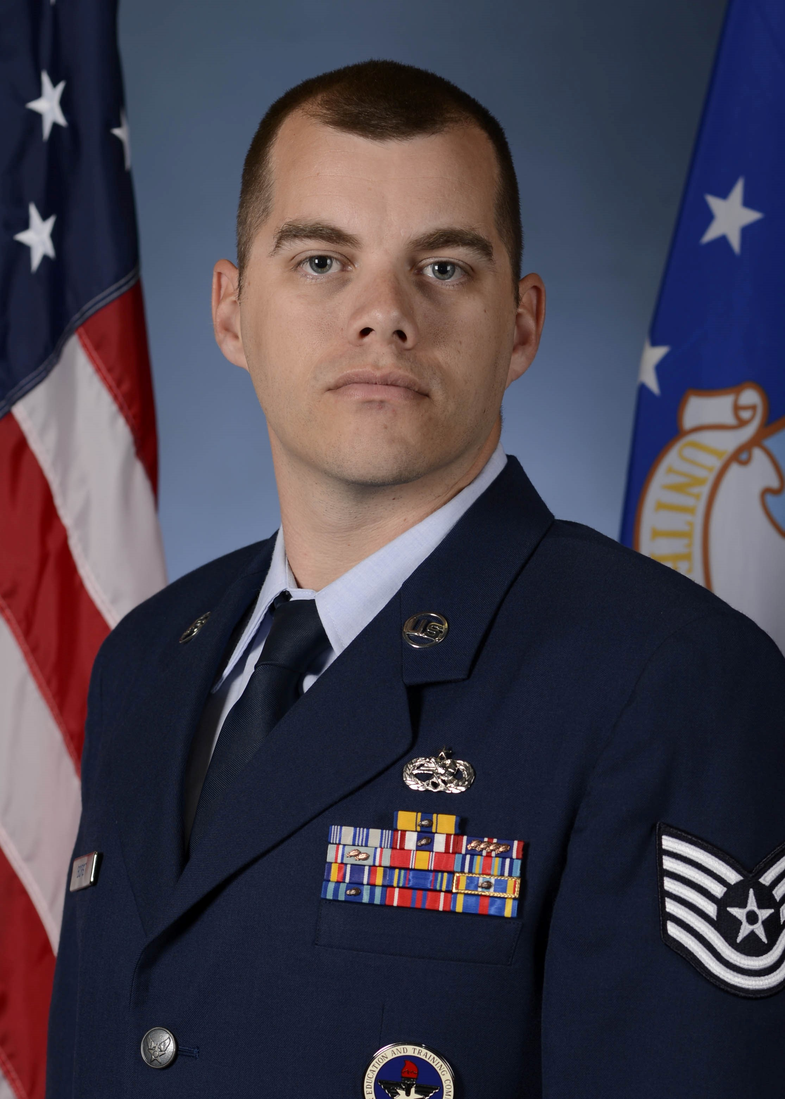
He enlisted in the Air Force in November 2006. His duties
have included backshop / flightline electrician, shift Supervisor,
AFREP technician and Field Training Detachment Instructor. He completed numerous deployments in direct support of operations such as Operation Enduring Freedom and Operation New Dawn.

EDUCATION

2008 Airman Leadership School, McGuire AFB, New Jersey
2014 2M Micro Miniature Soldering, Davis-Monthan AFB, Arizona
2015 Associate in Aviation Maintenance Technology, Community College of the Air Force
2016 Associate in Instructor of Tech and Military Science, Community College of the Air Force

ASSIGNMENTS

1. Jun 2007 - Aug 2012, Electrical / Environmental Systems Journeyman, 605th AMXS, McGuire AFB, NJ
2. Aug 2012 - Aug 2013, Electrical / Environmental Systems Craftsman, 20th CMS, Shaw AFB, SC
3. Aug 2013 - Dec 2015, AFREP Technician, 20th MXG, Shaw AFB, SC
4. Dec 2015 - Present, F16 Electrical / Environmental Systems Instructor, 372nd TRS / Detachment 202, Shaw AFB, SC

MAJOR AWARDS AND DECORATIONS
Air Force Commendation Medal
Air Force Achievement Medal
Meritorious Unit Award
AF Outstanding Unit Award

EFFECTIVE DATES OF PROMOTION

Staff Sergeant 01 May 2011
Technical Sergeant 01 November 2017

Air Force Commendation Medal
Air Force Achievement Medal
Meritorious Unit Award
AF Outstanding Unit Award
AF Good Conduct Medal
National Defense Service Medal
Global War On Terrorism Expeditionary Medal
Global War on Terrorism Service Medal
Air Force Expeditionary Service Ribbon with Gold Border
AF Longevity Service
USAF NCO PME Graduate Ribbon
AF Training Ribbon

