14 May 2019

372 TRS DET 2/CCT
321 Avocet St
Shaw AFB SC 29152-5006

Dear Student,

I am writing to inform you that you have been identified as requiring training for a FTD course. Please be informed that if you are flying into Columbia Metropolitan airport, a taxi from the airport to Shaw AFB, Sumter, SC will be approximately $100-$130. You will need to plan accordingly for the taxi fare.

Due to the limited number of available rooms, I recommend that you call the Carolina Pines Billeting office at (803) 895-3803 or DSN 965-3803 as early as possible to make reservations. However, please be aware that even with reservations you may still be required to move out of billeting to an off-base facility at any time as justified by the Carolina Pines Billeting personnel.

Our facility is located off of Shaw AFB on Hwy 441 and getting to our location from billeting or an off-base facility can be an issue. To eliminate any traveling issues, you SHOULD try to have a rental car authorized on your orders. Please be aware that getting a rental car authorized may not happen. If this is the case, contact us on your 1st day of class, and your instructor will pick you up in the main lobby of billeting. If you are staying off base please contact us and we will pick you up from your hotel. We will attempt to get a GOV issued for the class from our Transportation Squadron on the 1st day. For location of FTD, please see the map below.

You should ensure that your Government Travel Card (GTC) is active before you begin your travels. If you do not have a GTC, you will need to visit your financial office and request an advance on your per diem. You will be required to pay for your billeting in advance using your GTC, a personal credit card or cash.

I look forward to being your instructor, and if there is any way that I can be of assistance to you, please feel free to contact me at (803) 895-6043 or DSN 965-6043. Please respond to this email confirming your en-route training.

JAMEY K. SYKES, SMSgt, USAF
Detachment Superintendent

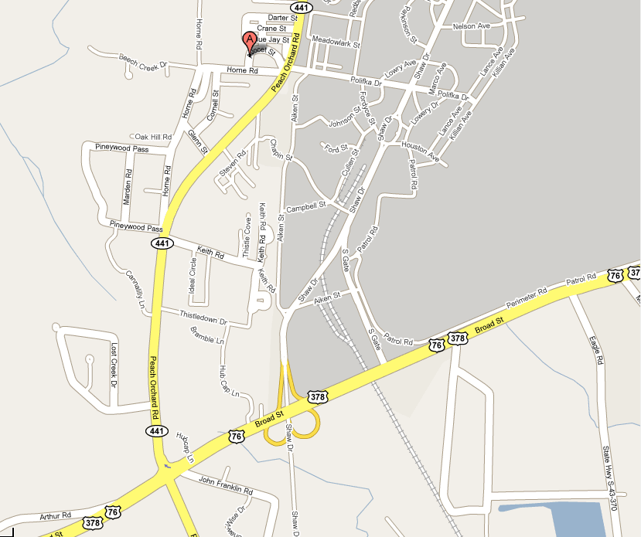
Main Gate
FTD

Directions:
- Go out the main gate to the right on to Hwy. 378
- At the light make a right on to Hwy 441.
- Continue down until you see the entrance to Field Training Detachment on the left. (If you pass Shaw View Cleaners you went too far.)

